πAssessment Schedule – 2011
Physics: Demonstrate understanding of aspects of heat (90939)
Evidence Statement
Correct significant figures are not required and units are required only in the questions that specifically ask for them.
Q | Achievement | Merit | Excellence
ONE  (a) | ONE idea. | Compare specific heat capacity; the specific heat capacity of aluminium is twice (greater) than that of cast iron (or numbers).  For the same temperature rise aluminium absorbs more heat energy than cast iron.
(b) | Correct graph is sketched as follows.  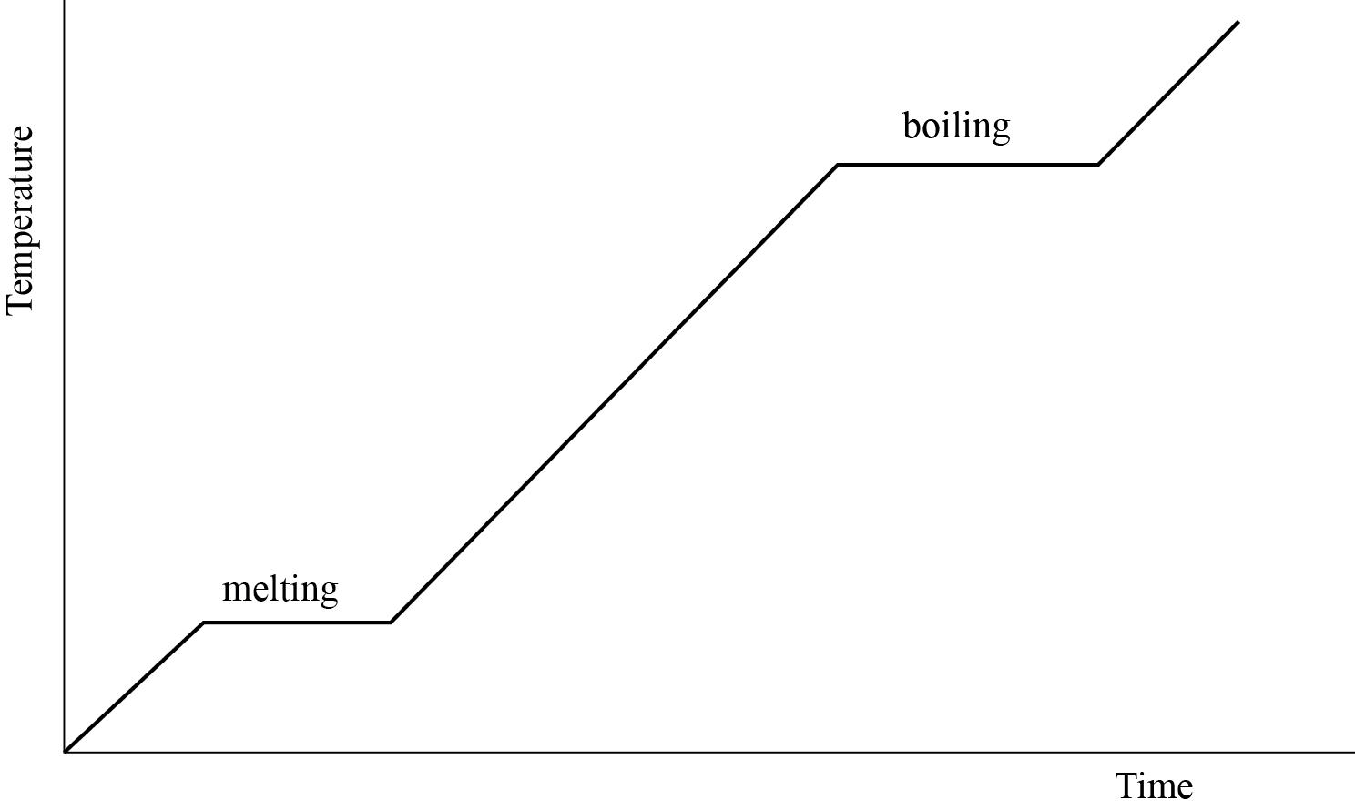
(c) | ONE of Both the melting and the boiling section is labelled correctly as in (b). | .
(d) | TWO ideas not linked. | THREE ideas. | • Thermal energy refers to the total amount of energy in a material.  • Temperature is the measure of the average kinetic energy of the particles in an object.  • The total amount of thermal energy in a material depends on its mass/no particles and temperature.  • Since the swimming pool has the larger mass/no particles, it contains more thermal energy than the hot aluminium plate.

Scoring Rubric
N0 | N1 | N2 | A3 | A4 | M5 | M6 | E7 | E8
No correct relevant physics. | Identifies 1 correct physics principle relevant to the part of the question. | 1A | 2A | 3A | 1M | 2M | 4 ideas for (d) uses mass. | All of (d) is correct. (including particles)

Q | Achievement | Merit | Excellence
TWO  (a) | Used Q as 23.2 and got an answer of 1.974 J kg^{–1} °C^{–1}. | Q = m c ΔT  23 200 = 0.050 × c × (250 – 15)  c = 23 200 / (0.50 × 235)  =1974 J kg^{–1} °C^{–1}
(b) | ONE correct answer is given. | Any TWO of the following answers are correct.  • The wooden frame is made from an insulator so that not much heat is lost from the plate by conduction to the frame.  • The hood over the barbecue traps the air above the hotplate to minimise the amount of heat lost from by convection / it reflects the heat back to reduce the heat lost by radiation.  • The burner cover around the burner minimises the amount of heat lost by convection and radiation to the surroundings.
(c) | Q = m c ΔT  Q = 1.65 × 897 × (300 – 20)  Q = 414 414 J  ONE correct calculation. | Q = m c ΔT  Q = 1.65 × 897 × (300 – 20)  Q = 414 414 J  P = E / t  t = E / P  t = 414 414 / 1380  t = 300 s  t = 300 / 60 = 5 min
(d) | Mentions heat loss to surroundings / environment | Describe some heat is lost to the surroundings through specific method eg conduction through metal guard. | Describe some heat is lost to the surroundings through specific method eg conduction through metal guard. And therefore to reach 300°C heat, more energy is need, so longer time

Scoring Rubric
N0 | N1 | N2 | A3 | A4 | M5 | M6 | E7 | E8
No correct relevant physics. | Identifies one physics principle / equation relevant to the part of the question. | 1A | 2A  OR  1M | 3A  OR  1A 1M. | 2M | 3M | (d) Missing either  to reach 300°C  OR  more energy needed. | All of (d) is correct.

Q | Achievement | Merit | Excellence
THREE  (a) | Mentions that foam is a poor conductor of heat. | The drinks are kept cool, as the foam traps air, which provides an insulating layer, reducing the transfer of heat into the bag by convection / convection.
(b) | The drinks are cooled down as the cooler blocks take heat from the bottles / surroundings. | The drinks are cooled down as the cooler blocks take heat from the drinks, to provide the latent heat of fusion as they melt.
(c) | EITHER Q₁ = m L  OR  Q ₂ = m c ΔT is calculated.  Ok not converted to kg  OR  Q ₂ = m c ΔT for lemonade  (m and ΔT must match) | Correct working and answer for  Q ₁ = m L and Q ₂ = m c ΔT, but the total is not given.  OR correct method, but  calculate Q ₂ = m c ΔT for lemonade (m and ΔT must match) . | Energy needed to melt the ice Q_{ice} = m L + m c ΔT  Q ₁ = m L  = 0.035 × 330 000  = 11 550 J  Q ₂ = m c ΔT  = 0.035 × 4 200 × 5  = 735 J  Q_{ice} = 11 550 + 735  = 12 285 J
(d) | Mentions evaporation of water / moisture causes her body to cool. | When the breeze blows moisture / water on Amy’s skin evaporates faster. The heat (latent heat of vaporisation) required for evaporation is absorbed/lost from Amy’s body and so she feels cooler.

Scoring Rubric
N0 | N1 | N2 | A3 | A4 | M5 | M6 | E7 | E8
No correct relevant physics. | Identifies one physics principle / equation relevant to the part of the equation. | 1A | 2A  OR  1M | 3A  OR  1A 1M | 2M | 3M | Correct working answer in seconds, but kg not converted. | All of (c) is correct.

Q | Achievement | Merit | Excellence
FOUR  (a) | They absorb sunlight / energy from the sun.
(b) | Mentions that the white wall will be less warm / reflect more heat / absorb less heat than the dark wall during the day.  OR  Comparison no link to rate of heating | The following answers are given.  • The white wall reflects most of the energy because the colour white is a good reflector of radiant energy and absorbs little so will heat more slowly.  • The dark wall absorbs most of the energy because the dark colour is a good absorber of radiant energy so will heat more quickly.
(c) | Mentions that the walls absorb energy during the day/radiate heat during the night. | Comparison of heat absorbed.  During the day the dark wall heats up more quickly because it absorbs more energy / sunlight so it reaches a higher temperature.  OR  Comparison of heat radiated  At night the dark wall loses heat faster/radiates heat more quickly (than the white wall). | Comparison of heat absorbed connected to temperature.  During the day the dark wall heats up more quickly because it absorbs more energy / sunlight so it reaches a higher temperature.  AND  Comparison of heat radiated connected to temperature.  At night the dark wall loses heat faster / radiates heat more quickly (than the white wall) to reach a lower temperature.
(d) | Energy absorbed by 1 m² of the tiles in one minute  = 80 / 100 × 60 000 = 48 000 J  OR  Correct second step with follow on error from the first step. | Energy absorbed by 1 m² of the tiles in one minute  = 80 / 100 × 60 000 = 48 000 J  Q = m c ΔT  48 000 = 68 × 920 × ΔT  ΔT = 48 000 / 62 560  = 0.77°C.

Scoring Rubric
N0 | N1 | N2 | A3 | A4 | M5 | M6 | E7 | E8
No correct relevant physics. | Identifies one physics principle / equation relevant to the part of the question. | 1A | 2A | 3A | 1M | 2M.  Must include (d) | Gives a correct description of heat effect, both day and night, and explains the cause of different heat effects | Gives a correct description of heat effect, both day and night, and explains the cause of different heat effects linked to temp.

Judgement Statement
 | Not Achieved | Achievement | Achievement  with Merit | Achievement  with Excellence
Score range | 0 – 9 | 10 – 18 | 19 – 24 | 25 – 32

